**2023 EVENT RULES & REGULATIONS**

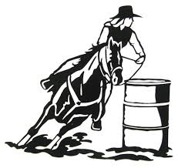

***2023 EDITION***

**Central Coast Sporting Horse**

**Association**

INCORPORATION NO: Y1696937

President: 0413 994 463 - Brad

Vice President: Graham Cunningham

Secretary: Jackie Wenzel

Treasurer: Erin Hulford

Web: [www.centralcoastsportinghorse.org.au](http://www.centralcoastsportinghorse.org.au)

***Rules are subject to change due to safety\committee decision – please keep them updated via the website***

**GENERAL RULES, REGULATIONS AND POINT SCORE HANDBOOK**

General Rules Apply to All Events

* Each horse may have only one start in the event.
* Horses are timed on the nose crossing the start and finish line.
* No rider is to be on the event course prior to event.
* In the event of a timing problem, the affected competitor is to be given another run after all other competitors.
* Only the timekeeper’s times will determine the final placings.
* No spectator timing will be permitted.
* A broken pole is treated the same as a pole knocked over.
* No equipment is to be handled unless otherwise stated in the event rules.
* No equipment is to be touched or held up to stop it falling.
* Elimination will result from a rider crossing the start/finish line before they have accurately completed the set course or knocking over the timing equipment.
* Elimination will result from excessive use of spurs, whip, or any other object.
* Under no circumstances will bullying or harassing be accepted.
* Arguing\bribing time keeps, or helpers will not be tolerated.
* Lead ins can have the pole half down – all other competitors must compete with the jump up.
* In the event a timer is knocked over and the time was seen by the timer the time will be noted but if the time was not noted the rider will be disqualified

**General Rules Apply to All Open Events.**

* Riders will only be shown each event once.
* Rider, spectators, timekeepers, and stewards are not permitted to call out and help riders during open events.
* Any equipment knocked over or dropped results in disqualification.

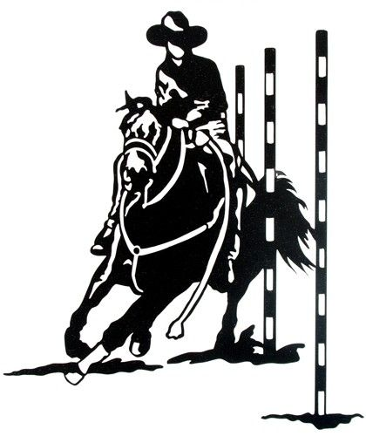

**Comp 1 2023 Events**

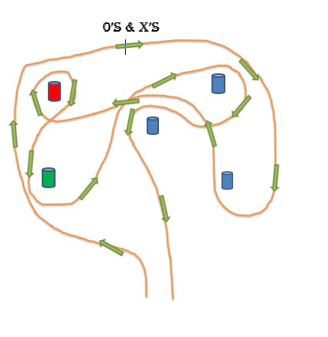

**CENTRAL COAST SPORTING**

**2023 COMP 1**

**Naughts & Crosses**

**Event: Running Start**

Rider starts the course by heading to the left of the course keeping to the left of the first barrel and making a right turn on the 2nd barrel heading right around the outside of barrel 3 & 4. Rider will turn right on the 4 and keeping in the middle of barrels 3 & 5.

Competitor will make a full right turn around the red barrel. Then a left turn around the green barrel making a final right hand turn around barrel #3 heading home keeping the middle barrel to the left of rifer\horse combo.

**ELEMINATION WILL RESULT FROM.**

* Error of course not rectified
* Knocked down pole\barrel or jump
* Holding up of any barrels.
* Dropped flag or knocked over flag bag\flag tin.
* Knocking of the start\finish poles without a time being recorded

***This is a timed event. Horses are timed on the nose crossing the start and finish lines.***

***Each horse may only have one start in the event.***

**CENTRAL COAST SPORTING**

**2023 COMP 1**

**BENDING**

Course: 5 Poles

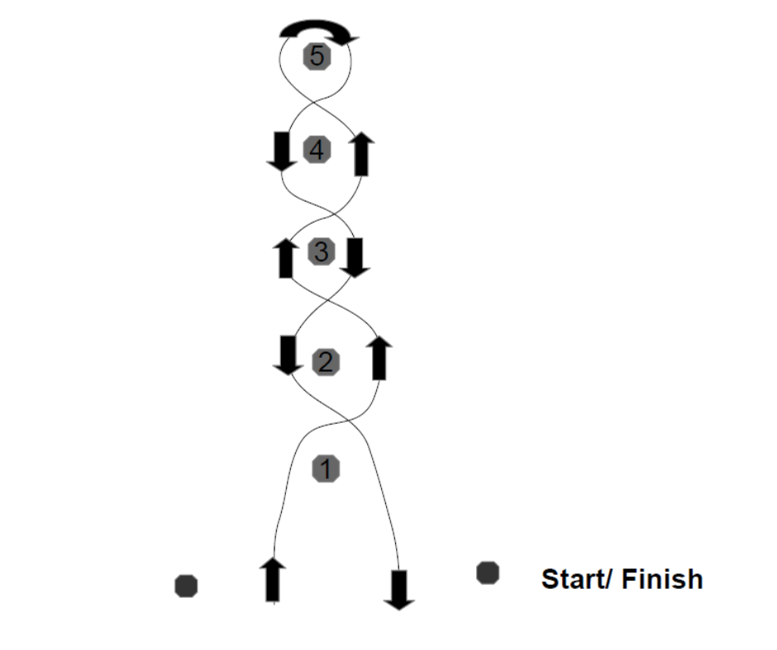

**Event: Running start**

The rider keeps pole 1 on their right and bends through to pole 5, making a right turn on pole 5 the rider proceeds to bend back through the poles and crosses the start/ finish line.

**Elimination will result from:**

* Error of course not rectified
* Knocked down pole\barrel or jump
* Knocking of the start\finish poles without a time being recorded poles

***This is a timed event. Horses are timed on the nose crossing the start and finish lines.***

***Each horse may only have one start in the event.***

**CENTRAL COAST SPORTING**

**2023 COMP 1**

**POST THE LETTER**

**Event: Running start.**

*The event may be run in either direction.*

1. The rider starts with the first pole to your right, then making a left turn on the letter box and delivering their letter with their left hand bending back through the pole and heading through the start/finish line.
2. The rider starts with the first pole to your left. Then making a right turn on the letter box and delivering their letter with their right hand bending back through the pole and heading through the start/finish line.

**ELEMINATION WILL RESULT FROM.**

* Error of course not rectified.
* Knocked down pole\barrel or jump
* Knocking of the start\finish poles without a time being recorded poles
* Dropped LETTER

***This is a timed event. Horses are timed on the nose crossing the start and finish lines.***

***Each horse may only have one start in the event.***

**CENTRAL COAST SPORTING**

**2023 COMP 1**

**LONG MINI BARREL**

Course: 3 Barrels.

1

2

3

1

3

2

**START|FINISH START|FINISH**

**Event: Running start.**

*The event may be run in either direction.*

1. The rider crosses the start line heads towards barrel 1 and turns left, proceeds to barrel 2 and completes a right, rides up to barrel 3 making another right and crosses the finish line.
2. The rider crosses the start line heads towards barrel 1 making a right turn, proceeds to barrel 2 and completes a left turn, then rides up to barrel 3 making another left and crosses the finish line.

**ELEMINATION WILL RESULT FROM.**

* Error of course not rectified
* Knocked down pole\barrel or jump
* Holding up of any barrels.
* Knocking of the start\finish poles without a time being recorded poles

***This is a timed event. Horses are timed on the nose crossing the start and finish lines.***

***Each horse may only have one start in the event.***

**CENTRAL COAST SPORTING**

**2023 COMP 1**

**DOUBLE JUMP**

**Event: Running start**

Rider will start heading through the start/finish line up to the first pole and making a right turn, he/she will proceed over both jumps` and head to the top pole to make a left turn, You will then head down to the two poles, keeping the first pole to the right of you & ducking between them to then stay on the left of the final pole and back over the start/finish line.

**ELEMINATION WILL RESULT FROM.**

* Error of course not rectified
* Knocked down pole\barrel or jump
* Holding up of any barrels.
* Knocking of the start\finish poles without a time being recorded poles

***This is a timed event. Horses are timed on the nose crossing the start and finish lines.***

***Each horse may only have one start in the event.***

**CENTRAL COAST SPORTING**

**2023 COMP 1**

**KEYHOLE BARREL**

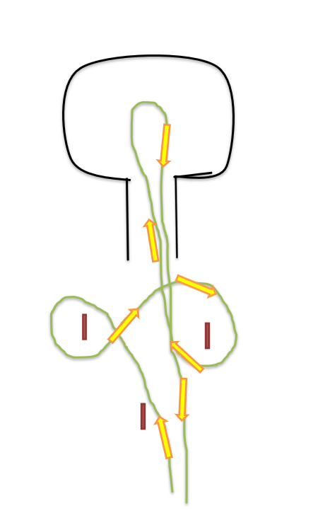

**Event: Running Start**

The rider bends through poles 1 to 3 (keeping pole 1 on their righthand side), enters the keyhole lane makes either a right or left turn in circle of the keyhole course, exits the keyhole lane, bends through poles 3 to 1(keeping pole 3 on their right-hand side) and crosses the start/ finish line.

**Elimination will result from:**

* Error of course not rectified
* Knocking of the start\finish poles without a time being recorded
* Stepping on or over the poly pipe keyhole boundary
* Not making the turn within the circle of the keyhole

***This is a timed event. Horses are timed on the nose crossing the start and finish lines.***

***Each horse may only have one start in the event.***

**CENTRAL COAST SPORTING**

**2023 COMP 1**

**Mushroom Run**

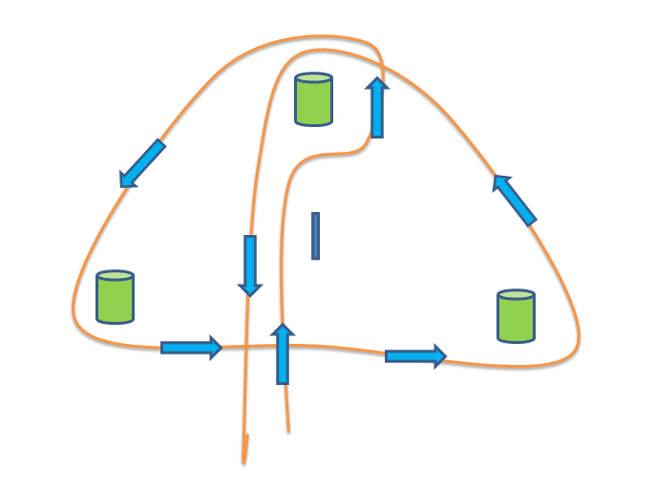

**Event: Running Start**

The rider will start running up to the pole and bend between the barrel and pole keeping the pole on the right-hand side and making a left turn around the barrel. Rider will then head right around the whole course keeping to the outside of the barrels, the rider will make a final left turn on the top barrel and heading home back through the starting poles

**ELEMINATION WILL RESULT FROM.**

* Error of course not rectified
* Knocked down pole\barrel or jump
* Holding up of any barrels.
* Knocking of the start\finish poles without a time being recorded

***This is a timed event. Horses are timed on the nose crossing the start and finish lines.***

***Each horse may only have one start in the event.***

**CENTRAL COAST SPORTING**

**2023 COMP 1**

**OPEN EM’ UP**

**Event: Running Start**

The rider will start by heading the top three poles, heading between the adjacent poles, and making a right turn, heading back through the pole, and making a left turn. Rider will then make a right turn on the last pole and bend between the 1st & 2nd poles. He\she will than head across to the adjacent poles and make a left turn on the furthest pole again bending between the two poles. Finally heading back through the two poles and over the start/finish lines.

**ELEMINATION WILL RESULT FROM.**

* Error of course not rectified
* Knocked down pole\barrel or jump
* Knocking of the start\finish poles without a time being recorded

***This is a timed event. Horses are timed on the nose crossing the start and finish lines.***

***Each horse may only have one start in the event.***

**Comp 2 2023 Events**



**CENTRAL COAST SPORTING**

**2023 COMP 2**

**SNAKE RUN**

**Event: Running Start**

The rider will start by heading to the top pole and making a **left turn,** rider will then head over to the opposite barrel and make a right turn. Continue down the line turn **left** on all the pole and **right** on the barrels.   
You will make a final **left** on the last pole and proceeding over the finish line.

**ELEMINATION WILL RESULT FROM.**

* Error of course not rectified
* Knocked down pole\barrel or jump
* Holding up of any barrels.
* Knocking of the start\finish poles without a time being recorded

***This is a timed event. Horses are timed on the nose crossing the start and finish lines.***

***Each horse may only have one start in the event.***

**CENTRAL COAST SPORTING**

**2023 COMP 2**

**BARREL RACE**

Course: 3 barrels 

**.**

**Event: Running Start**

***This event may be run in either direction***

* 1. The rider goes to barrel 1 and turns right, barrel 2 and turns left and barrel 3 and turns left then crosses the start/ finish line.

OR

* 1. The rider goes to barrel 2 and turns left, barrel 1 and turns right and barrel 3 and turns right then crosses the start/ finish line.

**Elimination will result from:**

* Error of course not rectified
* Knocked down pole\barrel or jump
* Holding up of any barrels.
* Knocking of the start\finish poles without a time being recorded

***This is a timed event. Horses are timed on the nose crossing the start and finish lines.***

***Each horse may only have one start in the event.***

**CENTRAL COAST SPORTING**

**2023 COMP 2**

**WESTERN BENDING**

Course: 5 Poles



**Event: Running start**

The rider keeps the poles on their left-hand side, turns left at pole 1, bends through the poles to pole 5, turns left at pole 5, bends back through the poles to pole 1, then turns left at pole 1 and crosses the start\finish line.

**Elimination will result from:**

* Error of course not rectified
* Knocked down pole\barrel or jump
* Knocking of the start\finish poles without a time being recorded

***This is a timed event. Horses are timed on the nose crossing the start and finish lines.***

***Each horse may only have one start in the event.***

**CENTRAL COAST SPORTING**

**2023 COMP 2**

**GUITAR RUN**

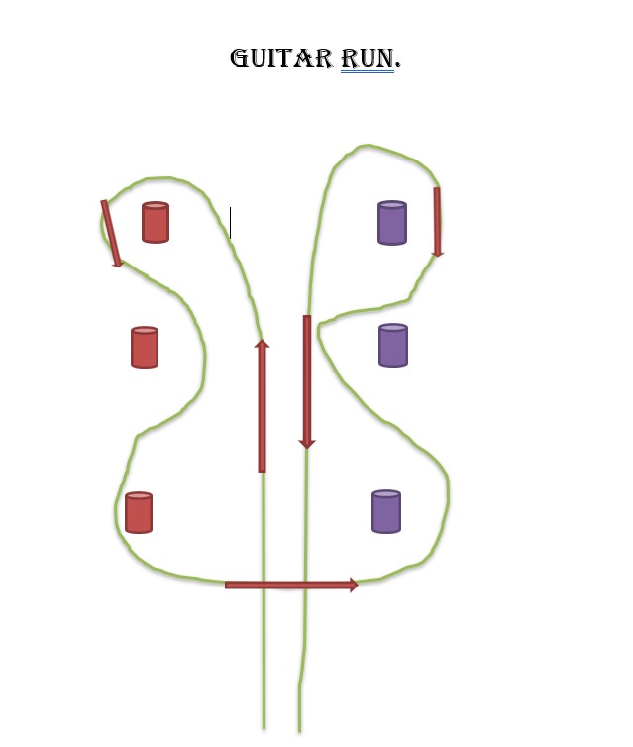

**EVENT; Running Start**

Rider starts by heading up the middle of the 6 barrels and makes a left turn on the furthest left barrel.

They will than proceed weaving through to the bottom red Barrel making a left turn and head straight across to the bottom purple barrel.

Weaving back up to the furthest purple barrel to make one last Left turn and heading home back through the center.

**ELIMINATION WILL RESULT FROM:**

* **Knocked barrel**
* **Error in course not rectified**
* **Knocked timers without a time being recorded**

***This is a timed event. Horses are timed on the nose crossing the start and finish lines.***

***Each horse may only have one start in the event.***

**CENTRAL COAST SPORTING**

**2023 COMP 2**

**BEND BARRELS**

Course: 3 Poles, 3 Barrels.

**Start/ finish**

3

2

1

**Event: Running Start**

The rider crosses the start line keeping the first pole on their right and bends through poles, the rider than continues to barrel 1 keeping the barrel on their left and makes a left turn on barrel 1, the rider proceeds to barrel 2 and makes a left turn on barrel 2, he/she rides to barrel 3 making another left on barrel 3 proceeding between the two poles and crosses the finish line with the last two poles on the riders right.

**Elimination will result from:**

* Error of course not rectified
* Knocked down pole\barrel or jump
* Holding up of any barrels.
* Knocking of the start\finish poles without a time being recorded

***This is a timed event. Horses are timed on the nose crossing the start and finish lines.***

***Each horse may only have one start in the event.***

**CENTRAL COAST SPORTING**

**2023 COMP 2**

**KEYHOLE**

Course: Keyhole.

* V
* V
* V
* V

**Start/ finish**

**Event: Walk up Start**

The rider walks up to cones than crosses start line entering the keyhole lane and makes either a left or right turn in the circle of the keyhole course he/ she than exits the keyhole lane and crosses the finish line.

**Elimination will result from:**

* Stepping on or over the poly pipe keyhole boundary.
* Not making the turn within the keyhole circle.
* Not walking up to the cones.
* Knocking of the start\finish poles without a time being recorded

***This is a timed event. Horses are timed on the nose crossing the start and finish lines.***

***Each horse may only have one start in the event.***

**CENTRAL COAST SPORTING**

**2023 COMP 2**

**PB RUN**

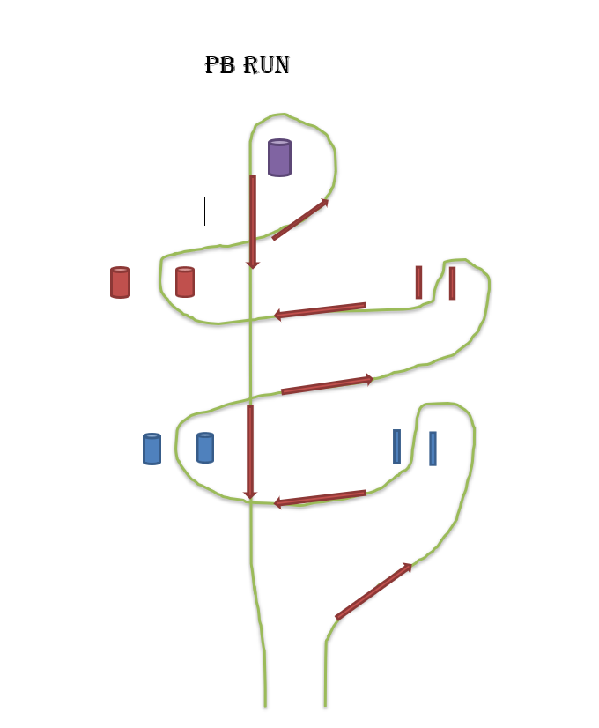

**EVENT; Running Start**

Rider starts by making a left turn on the blue pole & heading back through the middle of the duel poles, Rider will than head up through the middle of the two blue barrels making a right turn, repeating the same combination of turns on the red poles & barrels. The Rider will make a final Left turn on the purple barrel and continue back though the start\finish timers.

**ELIMINATION WILL RESULT FROM:**

* **Knocked barrel &\or Poles**
* **Error in course not rectified**
* **Knocked timers without a time being recorded**

***This is a timed event. Horses are timed on the nose crossing the start and finish lines.***

***Each horse may only have one start in the event.***

**CENTRAL COAST SPORTING**

**2023 COMP 2**

**SNAG RUN**

**Event: Running Start**

Rider will start by making a **RIGHT** turn between the first set of barrels, continuing up and making a **LEFT** turn between the two poles and again up to the barrel and making a **right** turn between the barrel and a **FULL LEFT** on the top barrel**.** Head back down and keeping the barrel and pole on your **RIGHT** and go between to the poles and down to the final two barrels and make a **LEFT** turn between the two barrels and back over the start/finish line/

**ELEMINATION WILL RESULT FROM.**

* Error of course not rectified
* Knocked down pole\barrel or jump
* Holding up of any barrels.
* Knocking of the start\finish poles without a time being recorded

***This is a timed event. Horses are timed on the nose crossing the start and finish lines.***

***Each horse may only have one start in the event.***